Please indicate membership type
Full | Associate | Student
Name:
Address:

Mobile number: Home number:
Email address:
FULL MEMBERS ONLY:
Would you like to advertise on the ALS website? Yes / No
Address will not appear on the website.
Website Profile:
Please give a short description about yourself and the service you provide.
Attach a passport size photograph for the website.

NRCPD Registered? Yes / No Expiry date:
Lipspeaking and other related qualifications (eg Deafblind, Notetaking, BSL level 1-6):

I understand to abide by the code of practice for lipspeakers. I agree that the above information may be kept on file in conjunction with ALS data protection policy.
Signed: |  | Date:
Return by email to: alsmembership@lipspeaking.co.uk

FOR OFFICE USE ONLY : Subscription Paid App Form DPForm Photo
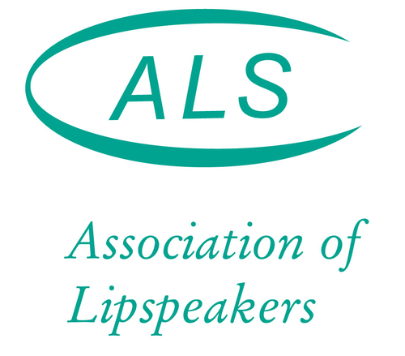

Membership Form

